**Objective**

The objective of this assignment is to launch an EC2 instance.

Solution:

Step 1: Login to your AWS account as IAM user

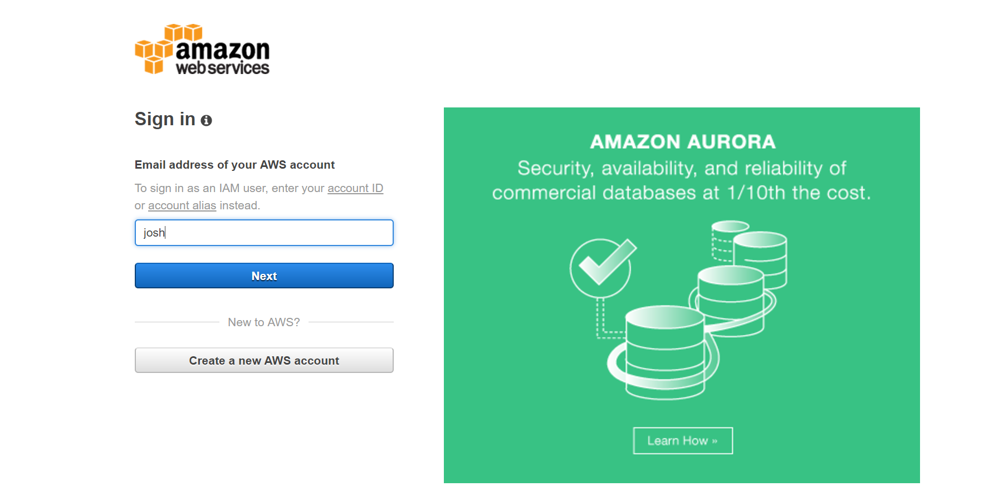

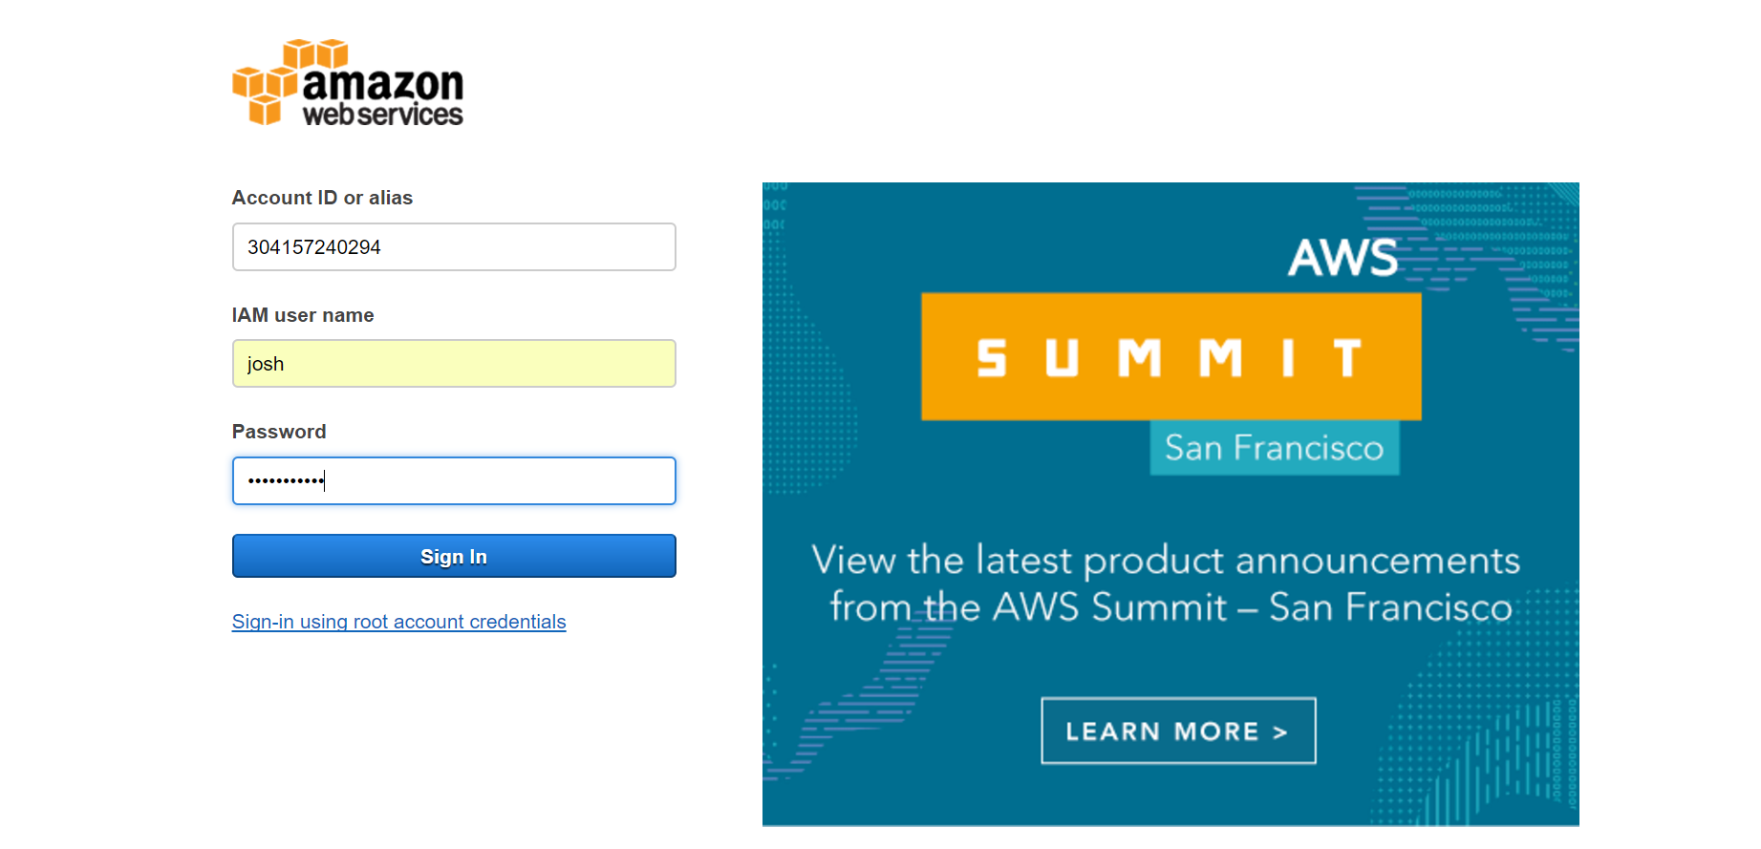



Step 2: Choose the AMI (Free trail – Ubuntu Server)

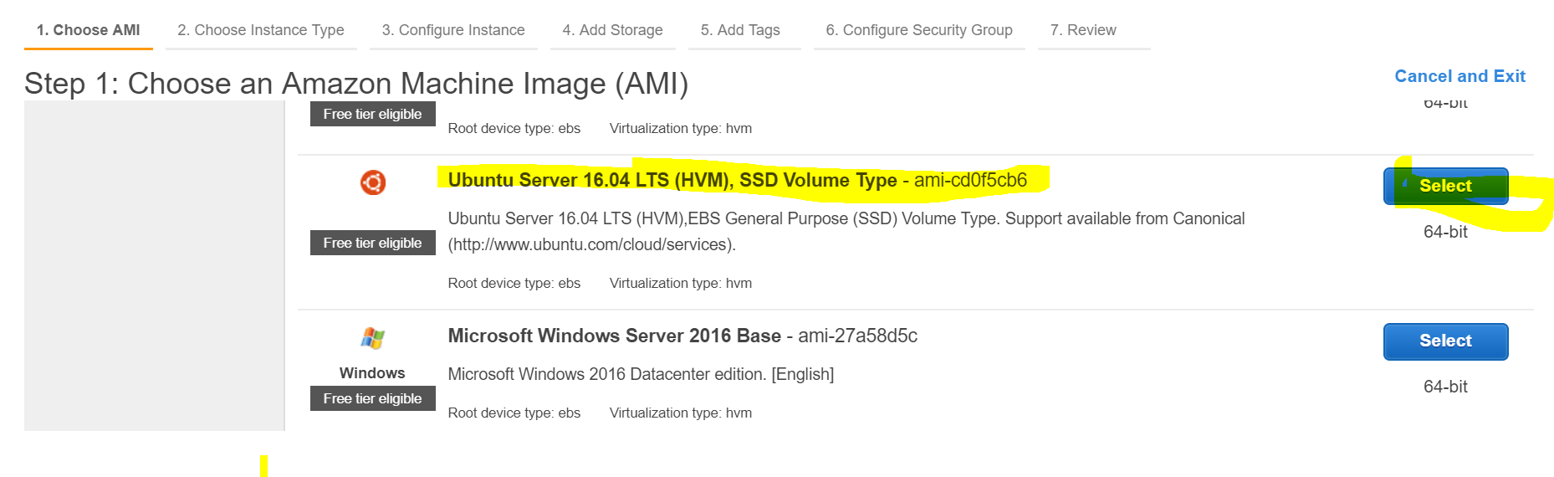

Step 3: Select Free Tier eligible options

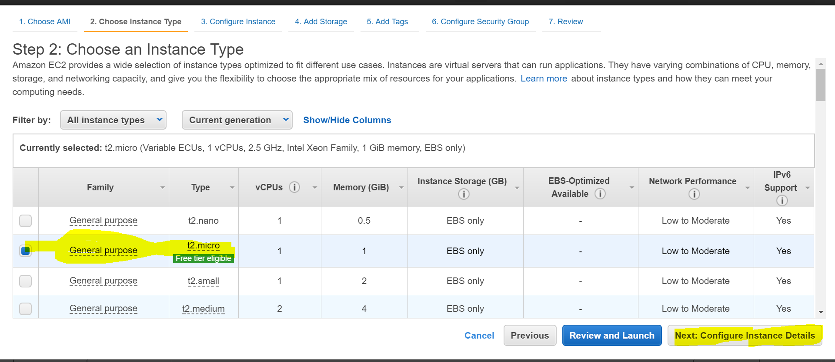

Step 4: Set up your Instance Details

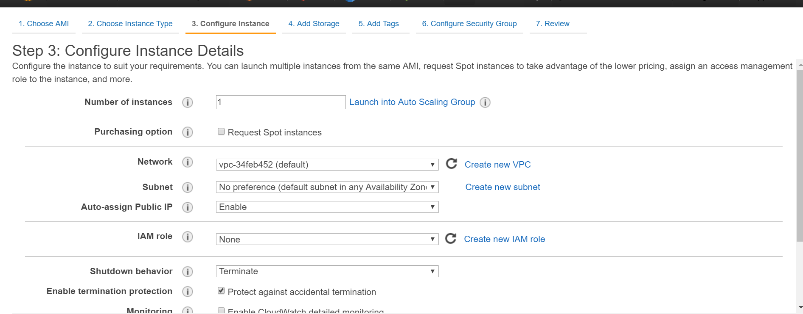

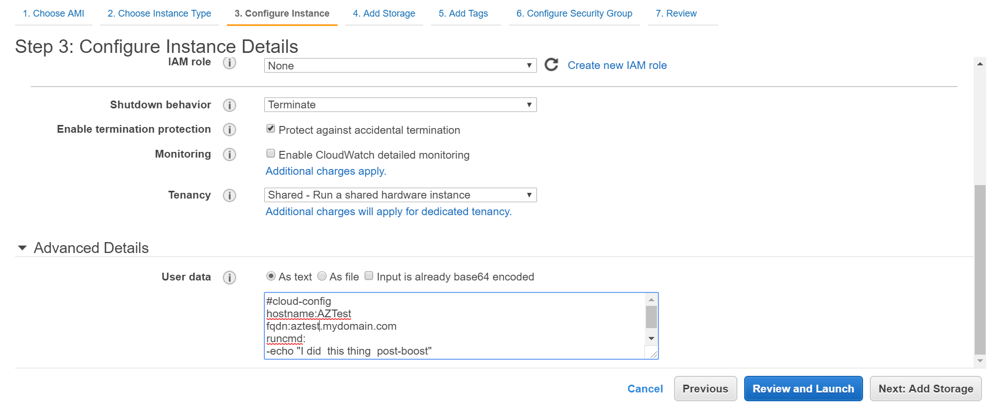

Step 5: Choose default storage for free trail

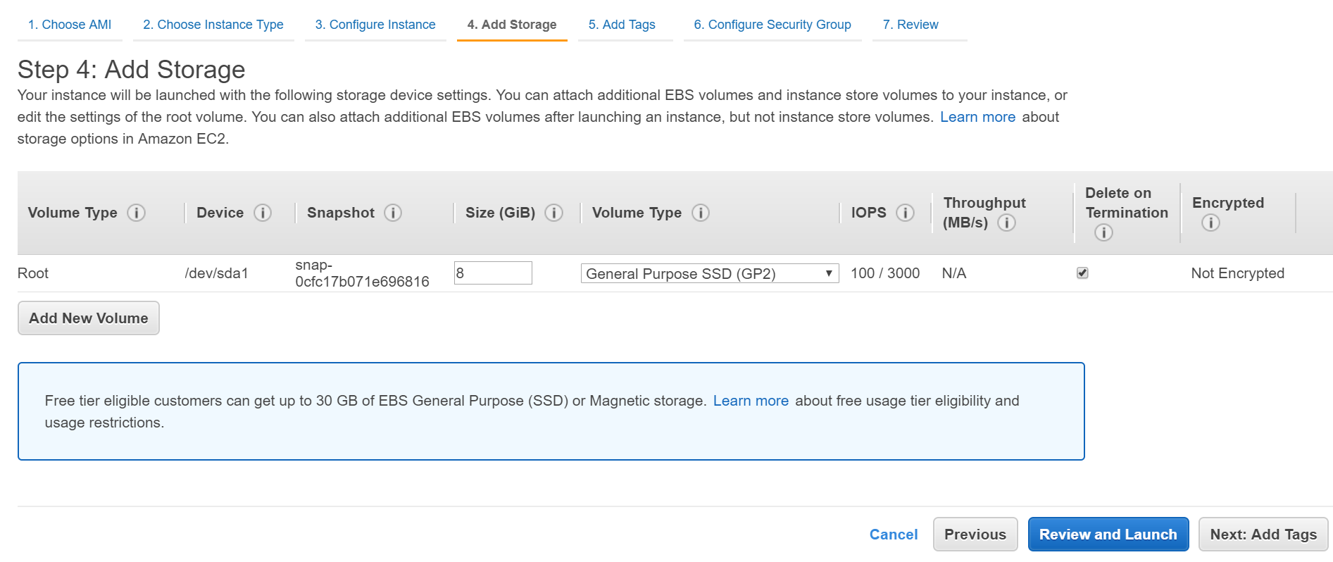

Step 6: Add Tags i.e, a name for your instance

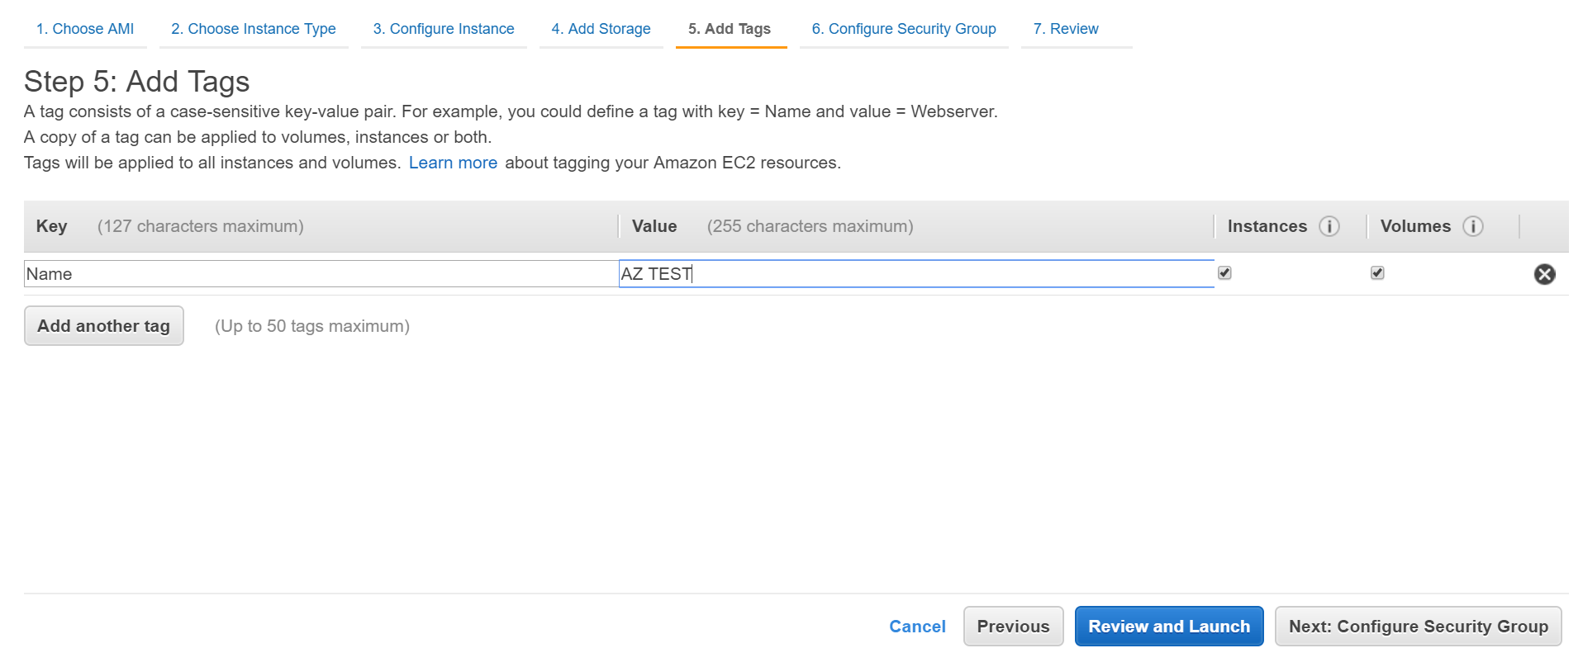

Step 7: Configure Security Group, add your system ip to source

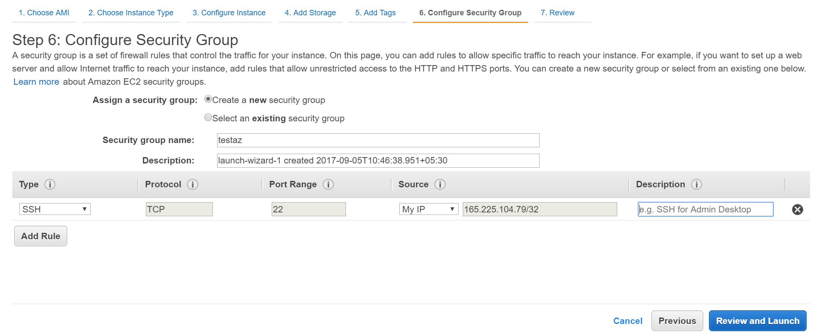

Step 8: Download the keypair and save it

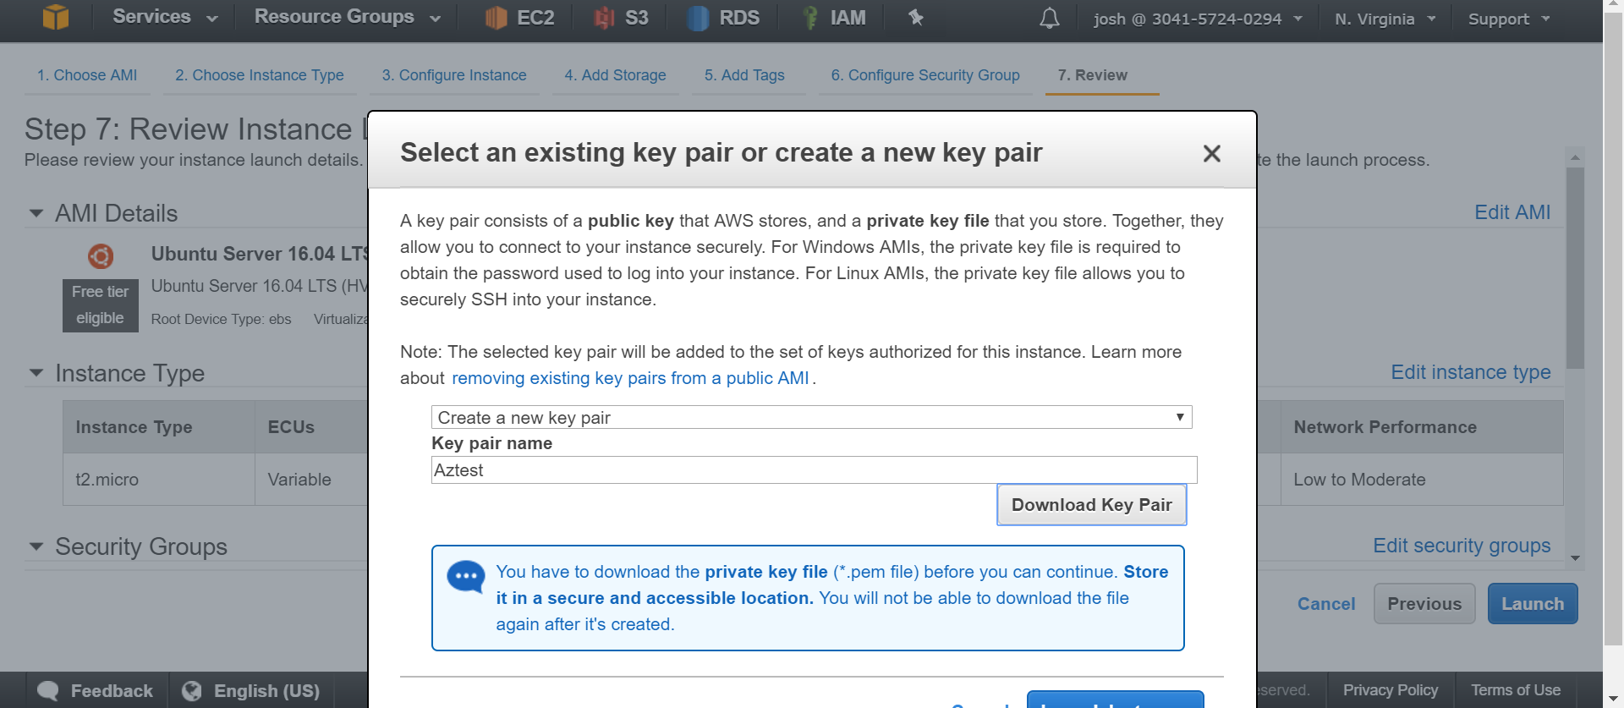

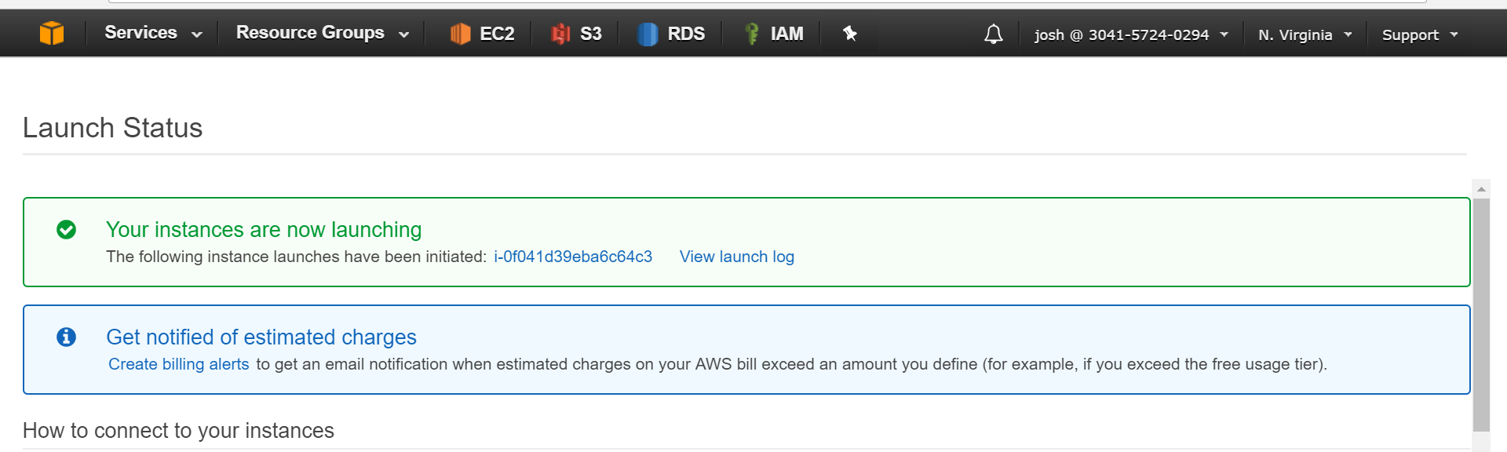

Step 9: Check the instance is running up and fine

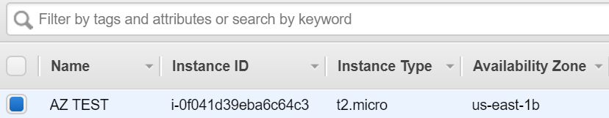

Step 10: Connect to the AWS Linux machine using the key pair downloaded.

